Project Planning Phase

**Project Planning Template (Product Backlog, Sprint Planning, Stories, Story points)**

|  |  |
| --- | --- |
| Date | 27 October 2023 |
| Team ID | Team-591797 |
| Project Name | Vitamin Detection Using Deep Learning |
| Maximum Marks | 5 Marks |
| Team Size | 4 |
| Team Members | Kasibhatla Srichandana Pothala Jaya Sri Sindhu  Karthikeya J  Bhanu Bhargavi Mamidikuduru |

Product Backlog, Sprint Schedule, and Estimation (4 Marks)

Use the below template to create product backlog and sprint schedule

|  |  |  |  |  |  |  |
| --- | --- | --- | --- | --- | --- | --- |
| **Sprint** | **Functional Requirement (Epic)** | **User Story Number** | **User Story / Task** | **Story Points** | **Priority** | **Team Members** |
| Sprint 1 | Registration & Login | USN-1 | As a user, I can register for the application by entering my email, password, and confirming my password. | 5 | High | srichandana |
| Sprint 1 |  | USN-2 | As a user, I will receive confirmation email once I have registered for the application | 5 | High | Sindhu |
| Sprint 3 |  | USN-3 | As a user, I can register for the application through Facebook,Instagram etc.. | 1 | Low | Karthik |
| Sprint 1 |  | USN-4 | As a user, I can log into the application by entering email & password | 5 | High | bhanu |
| Sprint 1 | Food item identification  & Vitamin analysis & Vitamin identification | USN-5 | As a dietitian, I want detailed vitamin breakdowns based on food images. | 8 | High | srichandana |
| Sprint 3 | Dashboard | USN-6 | The system should include a knowledge base that provides healthcare professionals with information on the patients daily vitamin intake. | 2 | Medium | Sindhu |
| Sprint 2 | Personalized notifications | USN-7 | As a parent, I want the system to notify me if my child's meal contains allergens. | 3 | High | Karthik |
| Sprint 2 | Food item identification  & Vitamin analysis & Vitamin identification | USN-8 | The system should accurately analyze images of packaged food items and verify the nutritional claims on product labels. | 8 | Medium | bhanu |
| Sprint 2 |  | USN-9 | As a food manufacturer, I want to verify the nutritional claims on my product labels. | 8 | High | srichandana |
| Sprint 4 | Scanning enhanced application | USN-10 | As a consumer, I want to scan food product barcodes for nutritional information. | 1 | Medium | Sindhu |
| Sprint 1 | Personalized vitamin tracker | USN-11 | As a fitness enthusiast, I want to track my daily vitamin intake. | 3 | High | Karthik |
| Sprint 3 | Statistical analysis | USN-12 | As a government agency worker, I want statistical reports on population dietary patterns. | 1 | Medium | bhanu |
| Sprint 3 | Audio feature | USN-13 | As a Visual impairment user, I want the audio description of detected vitamins. | 3 | Medium | karthik |
| Sprint 1 | Accurate analysis | USN-14 | As a user, I look for high accuracy in the results to use it on daily basis. | 5 | High | bhanu |

Project Tracker, Velocity & Burndown Chart: (4 Marks)

|  |  |  |  |  |  |  |
| --- | --- | --- | --- | --- | --- | --- |
| **Sprint** | **Total Story Points** | **Duration** | **Sprint Start Date** | **Sprint End Date (Planned)** | **Story Points**  **Completed (as on Planned End Date)** | **Sprint Release Date (Actual)** |
| Sprint-1 | 31 | 3 Days | 28 Oct 2023 | 01 Nov 2023 |  | 01 Nov 2023 |
| Sprint-2 | 19 | 3 Days | 01 Nov 2023 | 03 Nov 2023 |  | 04 Nov 2023 |
| Sprint-3 | 7 | 3 Days | 03 Nov 2023 | 06 Nov 2023 |  | 07 Nov 2023 |
| Sprint-4 | 1 | 4 Days | 06 Nov 2023 | 10 Nov 2023 |  | 11 Nov 2023 |

Velocity:

Imagine we have a 10-day sprint duration, and the velocity of the team is 20 (points per sprint). Let’s calculate the team’s average velocity (AV) per iteration unit (story points per day)

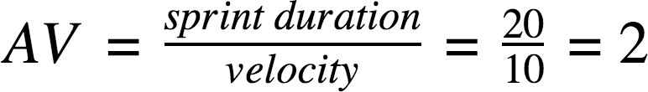

AV= 58/13 = 4.46

Burndown Chart:

A burn down chart is a graphical representation of work left to do versus time. It is often used in agile [software development](https://www.visual-paradigm.com/scrum/what-is-agile-software-development/) methodologies such as [Scrum](https://www.visual-paradigm.com/scrum/scrum-in-3-minutes/). However, burn down charts can be applied to any project containing measurable progress over time.

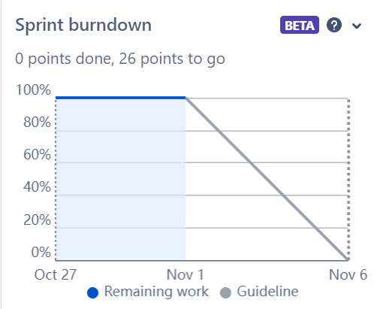

burndown chart of sprint-1

**Timeline:**

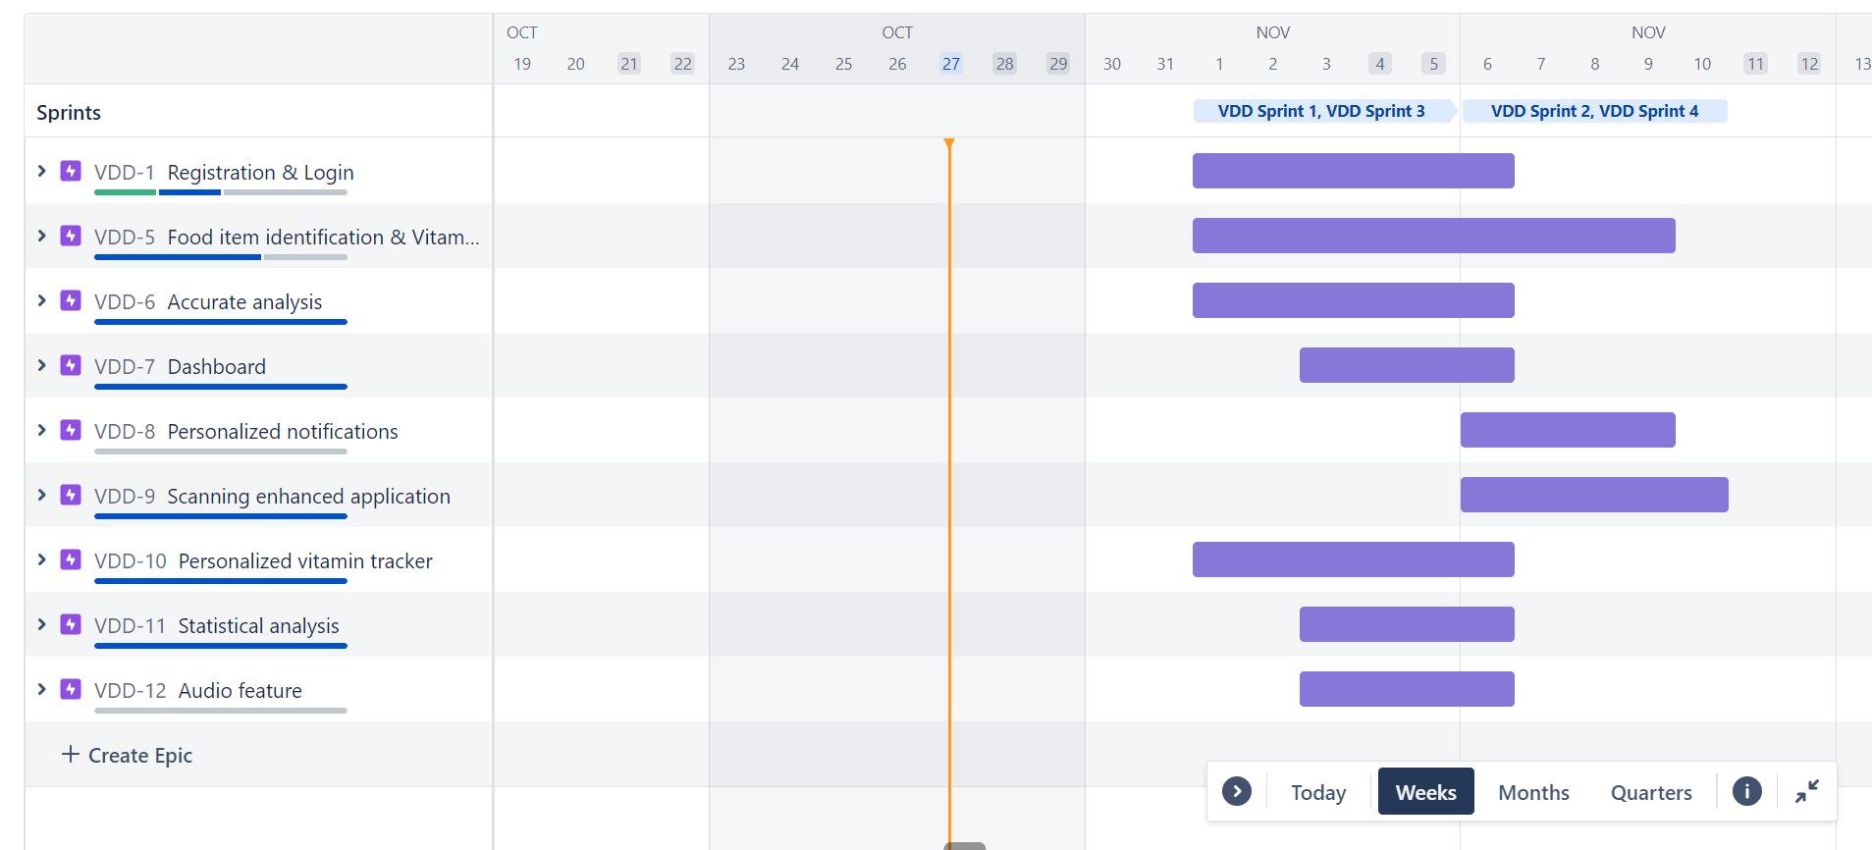

**Backlog:**

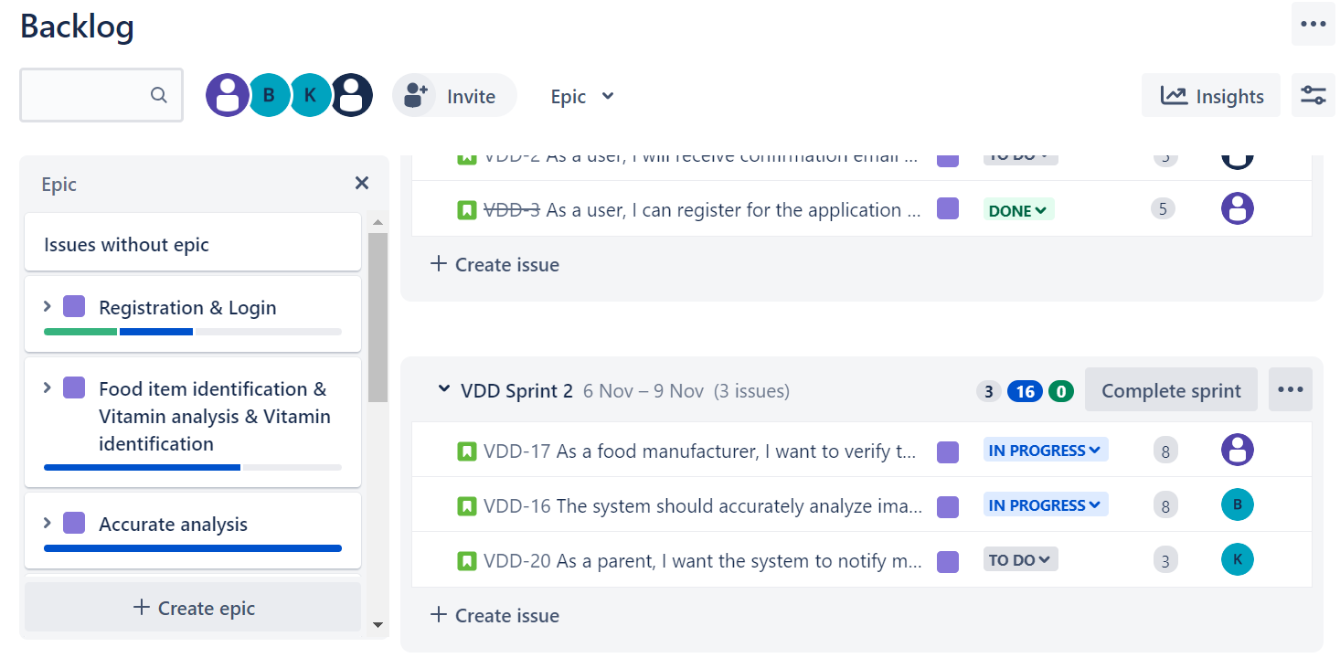

**Board:**

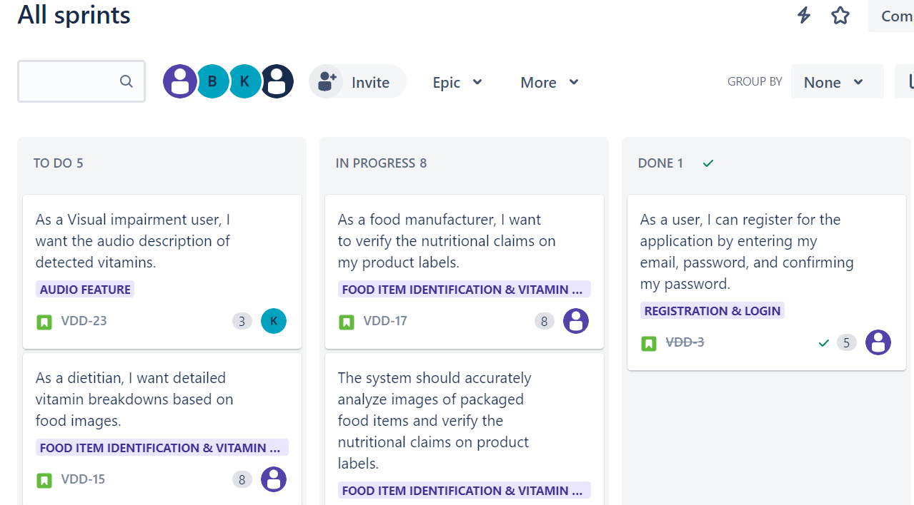

<https://www.visual-paradigm.com/scrum/scrum-burndown-chart/> <https://www.atlassian.com/agile/tutorials/burndown-charts>

Reference:

<https://www.atlassian.com/agile/project-management> <https://www.atlassian.com/agile/tutorials/how-to-do-scrum-with-jira-software> <https://www.atlassian.com/agile/tutorials/epics> <https://www.atlassian.com/agile/tutorials/sprints> <https://www.atlassian.com/agile/project-management/estimation> <https://www.atlassian.com/agile/tutorials/burndown-charts>